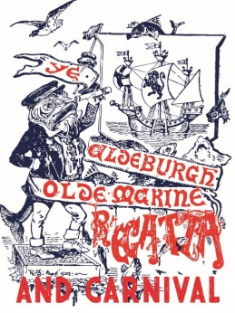
ALDEBURGH CARNIVAL
SPOT THE WINDOW
ENTRY FORM

Name | Tel No:
Address
There are 44 shops and business premises in Aldeburgh High Street taking part in this competition – all displaying a numbered ‘Spot the Window’ poster. In each case there is an item in the window that shouldn’t be there – find as many as you can and complete the form overleaf.
Make sure you enter the name of the premises and the item against the correct number. Please do not enter the premises to ask for clues.
Return your answer to the Moot Hall by Monday 31 August 2020 for a chance to win £25.00 prize. Answers will be posted on our website at the beginning of September. GOOD LUCK!
VISIT WWW.ALDEBURGHCARNIVAL.COM for details of other competitions:
‘DANDY DOGS’
‘GET THE BUG AND PAINT A PEBBLE’
‘GLAM JAM’
SEE YOU IN 2022
See you next year!
WHEN CARNIVAL WILL BE BACK ON
13TH 14TH and 15TH AUGUST!

No | Name of Premises | Item |  | No | Name of Premises | Item
1 |  |  |  | 23
2 |  |  |  | 24
3 |  |  |  | 25
4 |  |  |  | 26
5 |  |  |  | 27
6 |  |  |  | 28
7 |  |  |  | 29
8 |  |  |  | 30
9 |  |  |  | 31
10 |  |  |  | 32
11 |  |  |  | 33
12 |  |  |  | 34
13 |  |  |  | 35
14 |  |  |  | 36
15 |  |  |  | 37
16 |  |  |  | 38
17 |  |  |  | 39
18 |  |  |  | 40
19 |  |  |  | 41
20 |  |  |  | 42
21 |  |  |  | 43
22 |  |  |  | 44

