Aldeburgh Olde Marine Regatta and Carnival
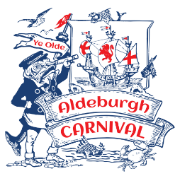


10k MINI MARATHON SPONSORED BY:
16th August 2026 10am
I certify that I am taking part in the 10k Mini Marathon entirely at my own risk and that I will not hold the organisers or any land owner responsible for any injury that may occur.
I will observe the Highway Code at all times and will not use the main road from Thorpeness to Aldeburgh.
Name……………………………………………………………………......
Address…………………………………………………………………......
.............................................................................................................
Expected completion time (tick Under 2 hours if not known):
Under 40 minutes |  | 40 – 70 minutes |  | Under 2 hours

For Official Use Only:  Entrant Number: |  | For entrants Under 14:  Age…………………….  Signature of responsible adult:  .....................................................  Print Name  .....................................................

Aldeburgh Olde Marine Regatta and Carnival

10k MINI MARATHON SPONSORED BY:
16th August 2026 10am
I certify that I am taking part in the 10k Mini Marathon entirely at my own risk and that I will not hold the organisers or any land owner responsible for any injury that may occur.
I will observe the Highway Code at all times and will not use the main road from Thorpeness to Aldeburgh.
Name……………………………………………………………………......
Address…………………………………………………………………......
.............................................................................................................
Expected completion time (tick Under 2 hours if not known):
Under 40 minutes |  | 40 – 70 minutes |  | Under 2 hours

For Official Use Only:  Entrant Number: |  | For entrants Under 14:  Age…………………….  Signature of responsible adult:  .....................................................  Print Name  .....................................................

